How to untether a BT connection for a C750 Scanner
Head to this link below:
https://doc1.scandocs.net/C750/en/system
Step 1 - Scan Restore Default Settings to untether the connection 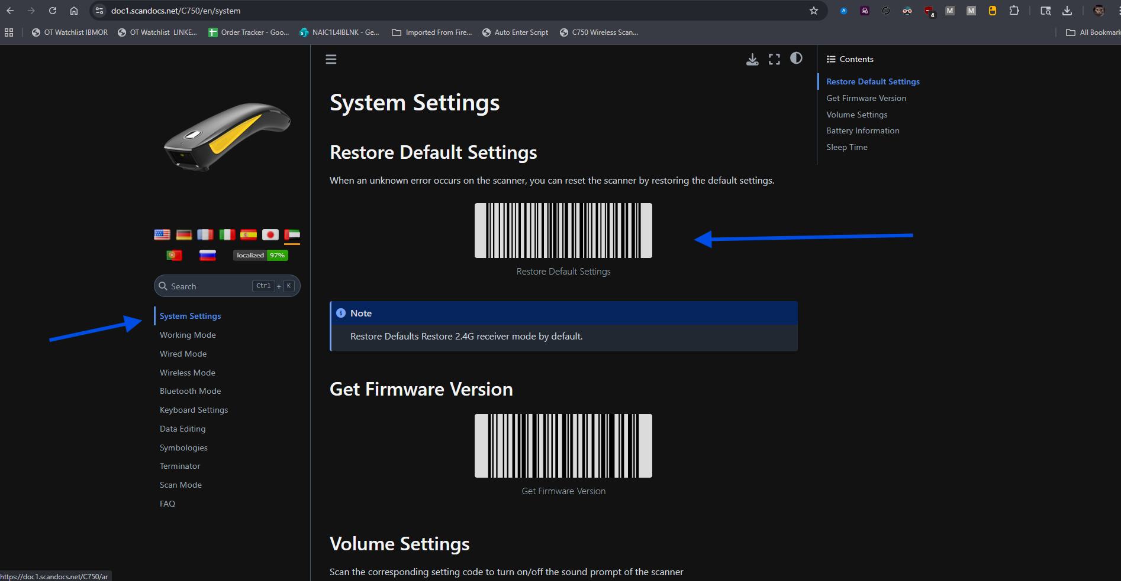
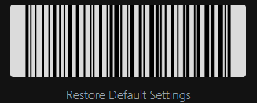
Step 2 – Scan Normal Mode just in case settings were changed 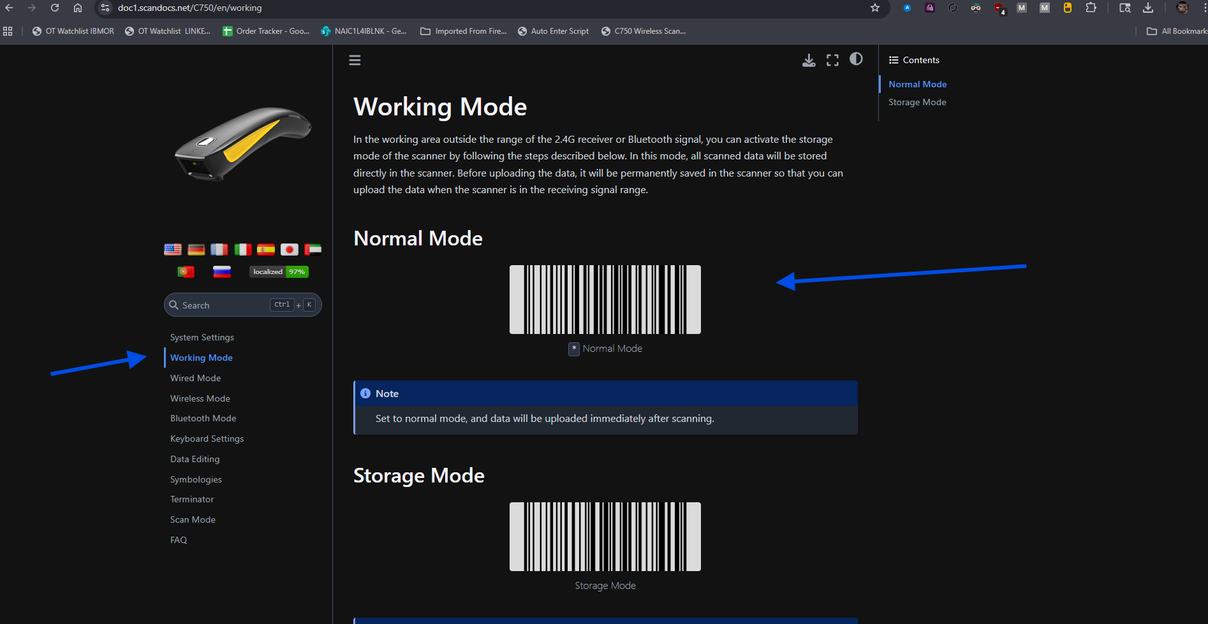
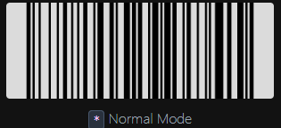
Step 3 – Scan All Caps (a->A) to ensure no matter what, your scans will convert into all caps
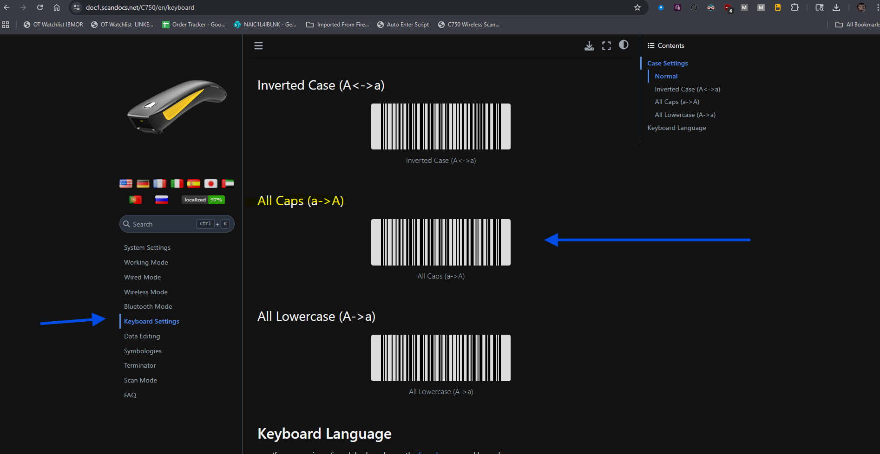
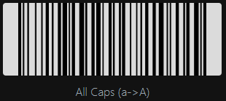

Your scanner should now be severed and ready to connect to any laptop, along with settings being restored to their native state and scans to be auto capitalized.
If you have any issues with these instructions please reach out to Benjamin.CullumJr@wwt.com

